Prepared For: Atlanta Public Schools

Prepared By: Michael Bower

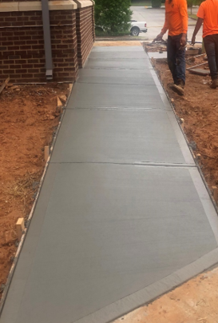 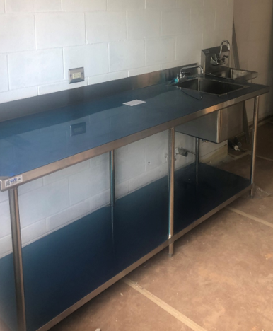

*Figure 1 S. Atl – Final Sidewalk Pour Figure 2 South Atlanta – Plumbing Installation*

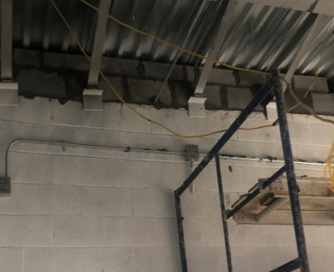

*Figure 3 Carver – Topping out CMU*

**Last Week’s Activities:**

* Carver HS – Electrical, mechanical and plumbing rough-in
* S. Atlanta HS – Electrical and plumbing rough-in.

**This Week’s Activities:**

* Carver HS – Top out cmu, plumbing rough-in.
* S. Atlanta HS – Mechanical insulation, plumbing fixture installation, electrical trim out, site clean-up and final grade. Transformer shutdown and pulling feeders to building.

**Next Week’s Activities:**

* Carver HS –mechanical rough-in, electrical rough-in, general trades, transformer shutdown to tie in feeders
* S. Atlanta HS – Drywall and finishes, inspections, request building power energization.

**Schedule:**

* The GC has shown improved manpower and progress consistently above and beyond previous efforts with Brown and Root continuing assistance with cash flow for the GC.

**Budget:**

* Construction Budget:
  + Carver: $826,402
  + S. Atlanta: $626,866
* Budget Status: On Budget
* Gross Billed to Date:
  + Carver: $607,630
  + S. Atlanta: $480,559